CHANGES HISTORY
PIC | Date | Remarks
Ghaida | 2018.04.23 | Created

TOC
- Coa
- Account
- Country
- Position
- Transaction
- JournalStatus
- Journal
- Journal Detail
- Debit Credit
- Journal Type
- Account Type

Diagram ENTITY RELATIONSHIP

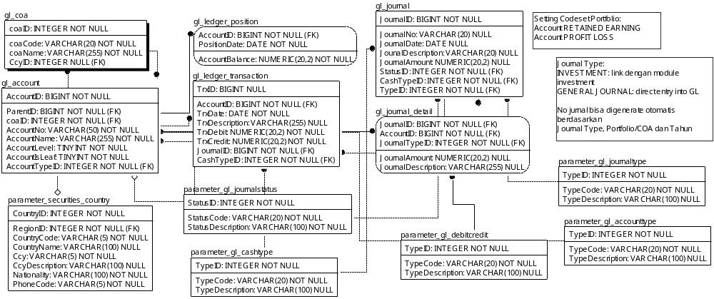

TABLE RELATIONSHIP
No | Table 1 | Table 2 | Type (1:1; 1:N; M:N) | Description
 | parameter_securities_country | gl_coa | M:N
 | gl_coa | gl_account | M:N
 | gl_account | gl_ledger_position | M:N
 | gl_account | gl_ledger_transaction | M:N
 | parameter_gl_accounttype | gl_account | M:N
 | gl_account | gl_account | M:N
 | parameter_gl_cashtype | gl_ledger_transaction | M:N
 | parameter_gl_cashtype | gl_journal | M:N
 | gl_journal | gl_ledger_transaction | M:N
 | parameter_gl_journalstatus | gl_journal | M:N
 | gl_journal | gl_journal_detail | M:N
 | parameter_gl_debitcredit | gl_journal_detail | M:N
 | gl_journal_type | gl_journal | M:N
 | gl_account | gl_journal_detail | M:N

Name |  | gl_coa
Objective
No | Column |  | Type | Rule  (PK, FK, Key, NN, Unik, Index) | Description
1. | coaID |  | Integer | NN
2. | coaCode |  | Varchar(20) | NN
3. | coaName |  | Varchar(255) | NN
4. | CcyID |  | Integer | FK, Null

SAMPLE DATA
No | Column | Sample 1 | Sample 2 | Sample 3 | Sample 4
1. | coaID
2. | coaCode
3. | coaName
4. | CcyID

Name |  | gl_account
Objective
No | Column |  | Type | Rule  (PK, FK, Key, NN, Unik, Index) | Description
1. | AccountID |  | BIGInteger | NN
2. | ParentID |  | BIGInteger | FK
3. | coaID |  | Integer | FK
4. | AccountNo |  | Varchar(50) | NN
5. | AccountName |  | Varchar(255) | NN
6. | AccountLevel |  | TINYInteger | NN
7. | AccountIsLeaf |  | TINYInteger | NN
8. | AccountTypeID |  | Integer | FK

SAMPLE DATA
No | Column | Sample 1 | Sample 2 | Sample 3 | Sample 4
1. | AccountID
2. | ParentID
3. | coaID
4. | AccountNo
5. | AccountName
6. | AccountLevel
7. | AccountIsLeaf
8. | AccountTypeID

Name |  | parameters_securities_country
Objective
No | Column |  | Type | Rule  (PK, FK, Key, NN, Unik, Index) | Description
1. | CountryID |  | Integer | NN
2. | RegionID |  | Integer | FK
3. | CountryCode |  | Varchar(2) | NN
4. | CountryName |  | Varchar(100) | Null
5. | Ccy |  | Varchar(5) | NN
6. | CcyDescription |  | Varchar(100) | Null
7. | Nationality |  | Varchar(100) | NN
8. | PhoneCode |  | Varchar(5) | NN

SAMPLE DATA
No | Column | Sample 1 | Sample 2 | Sample 3 | Sample 4
1. | CountryID | 1 | 2 | 3 | 4
2. | RegionID | 1 | 3 | 1 | 4
3. | CountryCode | ID | US | SG | JP
4. | CountryName | Indonesia | United States of America | Singapore | Japan
5. | Ccy | IDR | USD | SGD | JPY
6. | CcyDescription | Indonesian rupiah | US Dollar | Singapore Dollar | Japanese yen
7. | Nationality | Indonesia | American | Singapore | Japan
8. | PhoneCode | 62 | 1 | 65 | 81

Name |  | gl_ledger_position
Objective
No | Column |  | Type | Rule  (PK, FK, Key, NN, Unik, Index) | Description
1. | AccountID |  | BIGInteger | FK
2. | PositionDate |  | Date | NN
3. | AccountBalance |  | Numeric(20,2) | NN

SAMPLE DATA
No | Column | Sample 1 | Sample 2 | Sample 3 | Sample 4
1. | AccountID
2. | PositionDate
3. | AccountBalance

Name |  | gl_ledger_transaction
Objective
No | Column |  | Type | Rule  (PK, FK, Key, NN, Unik, Index) | Description
1. | TrxID |  | BIGInteger | Null
2. | AccountID |  | BIGInteger | FK
3. | TrxDate |  | Date | NN
4. | TrxDescription |  | Varchar(255) | Null
5. | TrxDebit |  | Numeric(20,2) | NN
6. | TrxCredit |  | Numeric(20,2) | NN
7. | JournalID |  | BIGInteger | FK
8. | CashTypeID |  | Integer | FK

SAMPLE DATA
No | Column | Sample 1 | Sample 2 | Sample 3 | Sample 4
1. | TrxID
2. | AccountID
3. | TrxDate
4. | TrxDescription
5. | TrxDebit
6. | TrxCredit
7. | JournalID
8. | CashTypeID

Name |  | parameter_gl_journalstatus
Objective
No | Column |  | Type | Rule  (PK, FK, Key, NN, Unik, Index) | Description
1. | StatusID |  | Integer | NN
2. | StatusCode |  | Varchar(20) | NN
3. | StatusDescription |  | Varchar(100) | NN

SAMPLE DATA
No | Column | Sample 1 | Sample 2 | Sample 3 | Sample 4
1. | StatusID | 1 | 2 | 3
2. | StatusCode | ENTRY | POSTED | DELETE
3. | StatusDescription | Entry | Posted | Delete

Name |  | parameter_gl_cashtype
Objective
No | Column |  | Type | Rule  (PK, FK, Key, NN, Unik, Index) | Description
1. | TypeID |  | Integer | NN
2. | TypeCode |  | Varchar(20) | NN
3. | TypeDescription |  | Varchar(100) | NN

SAMPLE DATA
No | Column | Sample 1 | Sample 2 | Sample 3 | Sample 4
1. | FieldCode | 1 | 2 | 3
2. | simpiID | OPERATING | INVESTING | FINANCING
3. | FieldType | Operational cashflow | Investment cashflow | Financing cashflow

Name |  | gl_journal
Objective
No | Column |  | Type | Rule  (PK, FK, Key, NN, Unik, Index) | Description
1. | JournalID |  | BIGInteger | NN
2. | JournalNo |  | Varchar(20) | Null
3. | JournalDate |  | Date | Null
4. | JournalDescription |  | Varchar(20) | Null
5. | JournalAmount |  | Numeric(20,2) | Null
6. | StatusID |  | Integer | FK
7. | CashTypeID |  | Integer | FK
8. | TypeID |  | Integer | FK

SAMPLE DATA
No | Column | Sample 1 | Sample 2 | Sample 3 | Sample 4
1. | JournalID
2. | JournalNo
3. | JournalDate
4. | JournalDescription
5. | JournalAmount
6. | StatusID
7. | CashTypeID
8. | TypeID

Name |  | gl_journal_detail
Objective
No | Column |  | Type | Rule  (PK, FK, Key, NN, Unik, Index) | Description
1. | JournalID |  | BIGInteger | FK
2. | AccountID |  | BIGInteger | FK
3. | JournalTypeID |  | Integer | Null
4. | JournalAmount |  | Numeric(20,2) | Null
5. | JournalDescription |  | Varchar(255) | Null

SAMPLE DATA
No | Column | Sample 1 | Sample 2 | Sample 3 | Sample 4
1. | JournalID
2. | AccountID
3. | JournalTypeID
4. | JournalAmount
5. | JournalDescription

Name |  | parameter_gl_debitcredit
Objective
No | Column |  | Type | Rule  (PK, FK, Key, NN, Unik, Index) | Description
1. | TypeID |  | Integer | NN
2. | TypeCode |  | Varchar(50) | NN
3. | TypeDescription |  | Varchar(100) | Null

SAMPLE DATA
No | Column | Sample 1 | Sample 2 | Sample 3 | Sample 4
1. | TypeID | 1 | 2
2. | TypeCode | DEBIT | CREDIT
3. | TypeDescription | Debit | Credit

Name |  | parameter_gl_journaltype
Objective
No | Column |  | Type | Rule  (PK, FK, Key, NN, Unik, Index) | Description
1. | TypeID |  | Integer | NN
2. | TypeCode |  | Varchar(20) | NN
3. | TypeDescription |  | Varchar(100) | Null

SAMPLE DATA
No | Column | Sample 1 | Sample 2 | Sample 3 | Sample 4
1. | TypeID | 1 | 2
2. | TypeCode | INVT | GJ
3. | TypeDescription | Investment Journal | General Journal

Name |  | parameter_gl_accounttype
Objective
No | Column |  | Type | Rule  (PK, FK, Key, NN, Unik, Index) | Description
1. | TypeID |  | Integer | NN
2. | TypeCode |  | Varchar(20) | NN
3. | TypeDescription |  | Varchar(100) | Null

SAMPLE DATA
No | Column | Sample 1 | Sample 2 | Sample 3 | Sample 4
1. | TypeID | 1 | 2 | 3 | 4
2. | TypeCode | ASSET | LIABILITIES | CAPITAL | INCOME
3. | TypeDescription | Asset | Liabilities | Capital | Income

